UNIVERSITY OF DAR ES SALAAM


COLLEGE OF INFORMATION AND COMMUNICATION TECHNOLOGIES
DEPARTMENT OF COMPUTER SCIENCE AND ENGINEERING
IS335 / CS498: Final Year Project Report – Mid of Semester Two

Project Title: COFFEECHAIN, Design and Implementation of a Blockchain-Enabled Coffee Fertilizer Supply Traceability and Distribution Audit Platform

Student Name | Registration Number | Programme
SIRILI ALBERT AMMI | 2022-04-00378 | Bsc. CEIT
VICTOR ASEL KABUGUMILA | 2022-04-03344 | Bsc. CEIT
MAXIMILIAN KAYOMBO | 2022-04-03941 | Bsc. CEIT
JOSHUA MBWILO | 2022-04-07061 | Bsc. CEIT

Supervisor’s Name: DR. ELLEN KALINGA
Supervisor’s Signature: ……………………

DECLARATION
We, the undersigned, hereby declare that this project report titled “Coffee Chain: Design and Implementation of a Blockchain-Enabled Digital Records and Analytics Platform for Coffee Cooperatives” is our own original and unaided work. All sources of information used in the preparation of this report have been fully acknowledged and appropriately referenced.
This project report has not been submitted, either in whole or in part, to any other institution for the award of a degree or for any academic examination.
Signatures:
...............................................  Sirili Albert Ammi  Date: ................................ | ............................................  Victor Asel Kabugumila  Date: .................................
...............................................  Joshua Mbwilo  Date: ................................  Supervisor’s signature: | ............................................  Maxmillian Issiah Kayombo  Date: .................................
.............................................
Dr. Ellen Kalinga
Date: ................................

ACKNOWLEDGEMENT
We first would like to thank the Almighty God for the being with us throughout the development till the completion of the project.
We would also like to express our sincere gratitude to our supervisor, Dr. Ellen Kalinga, for the guidance, constructive feedback, and academic support provided throughout the development of this project. Her insights and encouragement were invaluable in shaping the direction and quality of this work.
We also extend our appreciation to panel supervisors for providing us with the constructive challenges, additions, knowledge and resources that contributed to the successful completion of this project.
And lastly, special thanks go to our colleagues and peers for their cooperation, discussions, and moral support during the project period. Finally, we are grateful to our families and friends for their continuous encouragement and support throughout our academic journey.

ABSTRACT
Coffee cooperatives play a vital role in organizing smallholder farmers, managing agricultural inputs, aggregating produce, and facilitating payments. However, many cooperatives continue to rely on manual or fragmented digital record-keeping systems, which are prone to data inconsistencies, loss, and lack of transparency. These challenges hinder accountability, auditability, and trust among farmers, cooperative management, and oversight bodies.

This project presents Coffee Chain, a blockchain-enabled digital records and analytics platform designed to improve transparency and accountability in coffee cooperatives. The system records cooperative operations such as input distribution, seasonal coffee production, and farmer payment records using a permissioned blockchain to ensure data integrity, immutability, and traceability. In addition, the platform provides analytics and reporting features that support cooperative management and authorized institutions in monitoring performance and decision-making.

The system was developed using a web-based architecture and evaluated through functional testing to assess its effectiveness in addressing identified challenges.
Table of Contents
DECLARATION i
ACKNOWLEDGEMENT ii
ABSTRACT iii
LIST OF FIGURES vii
LIST OF TABLES viii
CHAPTER ONE 1
1.1 Background of the Project 1
1.2 Statement of the Problem 1
1.3 Project Objectives 2
1.3.1 Main Objective 2
1.3.2 Specific objectives 2
1.4 Significance of the Report 3
1.5 Scope of the Project 4
1.6 Project Report Organization 4
CHAPTER TWO 5
LITERATURE REVIEW 5
2.1 Overview of Coffee Cooperative Management Systems 5
2.2 Input and Output Flows in Coffee Cooperatives 6
2.2.1 The Top-Down Flow: Input Distribution 6
2.2.2 The Bottom-Up Flow: Produce Aggregation 6
2.3 Challenges in Existing Coffee Cooperative Tracking Systems 7
2.4 Blockchain Technology in Coffee Supply Chain Management 7
2.5 Distributed Nodes and Accountability in Coffee Cooperatives 7
2.6 Related Works on Digital and Blockchain-Based Coffee Systems 8
2.7 Weaknesses of Existing Coffee Cooperative Navigation and Tracking Approaches 8
2.8 Project Gap 9
CHAPTER THREE 10
METHODOLOGY 10
3.1 Development Methodology 10
3.2 Proper Development Approach 10
2.1 System Implementation 12
3.4 System Testing, Performance Evaluation, and Deployment 13
CHAPTER FOUR 14
COFFEECHAIN SYSTEM ANALYSIS AND DESIGN 14
4.1 Data Collected 14
4.1.1 Data Collected from Questionnaires 14
4.1.2 Data Collected from Interviews 15
4.1.3 Summary of Identified Vulnerabilities 16
4.2 System Functionalities 17
4.2.1 Core System Modules 17
4.2.2 Functional Requirements 17
4.2.3 Non-Functional Requirements 19
4.3 Non-Functional Requirements 20
4.3.1 Primary actors 20
4.3.2 Secondary actors 21
4.4 Use Case Diagrams and Use Case Description 23
4.4.1 Use Case 1: Distribution of Agricultural Inputs 23
4.4.2 Use Case 2: Production Data Logging 24
4.4.3 Use Case 3: Supply Chain Audit and Reporting 25
4.4.4 Use Case: Manage User Accounts 26
4.4.5 Use Case: Assign Roles and Permissions 27
4.4.6 Use Case: Register Blockchain Node 27
4.8 Database Architecture 36
References 37

LIST OF FIGURES
Figure 3.2-1Agile development methodology diagram ------------------------------------------------ 11
Figure 4.4.6-1 Use case of Diagram of CoffeeChain system ------------------------------------------ 29
Figure 4.4.6-2 Production logging ------------------------------------------------------------------------ 30
Figure 4.4.6-3 Record Fertilizer distribution with USSD farmer confirmation --------------------- 31
Figure 4.4.6-4 Managing user account sequence diagram --------------------------------------------- 32
Figure 4.4.6-5 CoffeeChain system class diagram ------------------------------------------------------ 33

LIST OF TABLES
Table 2.1-1 Area that Produce Coffee in Tanzania ......................................................................... 6 Table 3.2-1 Presents the specific objectives of the project and the corresponding approaches that will be applied to achieve each objective ..................................................................................... 11
Table 3.4-1 The planned testing and performance evaluation methods for this project ............... 13
Table 4.2.3-1 Non-Functional Requirements for CoffeeChain ..................................................... 19
Table 4.3.2-1 System Actors for CoffeeChain .............................................................................. 22
Table 4.4.1-1 Distribution of Agricultural Inputs use case ........................................................... 23
Table 4.4.2-1 Record Seasonal Coffee Production use case ......................................................... 24
Table 4.4.3-1 Generate Supply Chain Audit Report use case ....................................................... 25
Table 4.4.4-1 Manage User Accounts use case ............................................................................. 26
Table 4.4.5-1 Assigning Roles and Permissions use case ............................................................. 27
Table 4.4.6-1 Registering Blockchain Node use case ................................................................... 28
Table 4.4.6-2 Entity Relationship Diagram illustrating database structure .................................. 35

CHAPTER ONE

1.1 Background of the Project
Agriculture remains one of the most important sectors in Tanzania, contributing significantly to food security, employment, rural livelihoods, and national economic development. Among the major agricultural activities, coffee farming plays an important role as both a source of household income and a contributor to export earnings. The productivity and quality of coffee production are highly dependent on the effective use of agricultural inputs, particularly fertilizers, which are essential for improving soil fertility, increasing crop yields, and maintaining sustainable farming practices.
The distribution of fertilizers within agricultural supply chains involves multiple actors, including fertilizer suppliers, distributors, cooperatives, agro-dealers, retailers, regulatory authorities, and farmers. In coffee-growing regions, fertilizers are commonly distributed through cooperatives and agricultural retail networks before reaching individual farmers. Due to the large number of participants involved, maintaining accurate records, ensuring accountability, and verifying the movement of fertilizer supplies across the distribution chain becomes a complex process.
Despite ongoing efforts to digitize agricultural input management, several operational challenges continue to affect fertilizer distribution systems. These challenges include fragmented record management, limited end-to-end traceability, delayed verification of transactions, inconsistencies in stock reconciliation, and difficulties in auditing fertilizer movement between supply-chain actors. In some cases, counterfeit fertilizers, undocumented redistribution, and unauthorized stock diversion further weaken transparency and accountability within agricultural distribution ecosystems. Such issues may negatively affect coffee farmers by limiting access to verified agricultural inputs and reducing confidence in the integrity of supply channels.
Conventional centralized database systems are commonly used for storing operational distribution records. However, centralized systems depend heavily on a single controlling authority for data verification and management, making them vulnerable to record manipulation, unauthorized alterations, and limited interoperability across independent stakeholders. Additionally, where multiple organizations participate in the supply chain, establishing shared trust and independently verifiable transaction histories becomes increasingly difficult.
Blockchain technology has emerged as a potential solution for improving transparency, traceability, and integrity in distributed information systems. Unlike traditional centralized databases, blockchain provides immutable and tamper-evident transaction records that can be independently verified by authorized participants. Within agricultural supply chains, blockchain technology can support fertilizer batch traceability, improve accountability during inventory transfers, and strengthen auditability across suppliers, retailers, cooperatives, and farmers.
This project therefore proposes CoffeeChain, a blockchain-enabled fertilizer supply traceability and distribution audit platform designed to support transparency and accountability within agricultural input distribution processes.

1.2 Statement of the Problem
The distribution of fertilizers within agricultural supply chains involves multiple independent actors, including suppliers, cooperatives, agro-dealers, retailers, regulatory authorities, and farmers. Although existing digital systems support certain aspects of fertilizer allocation and record management, challenges related to fragmented data visibility, inconsistent verification processes, and limited end-to-end traceability across the supply chain still persist.
In many cases, fertilizer distribution records are maintained using centralized systems that provide limited mechanisms for independently verifying the authenticity and integrity of transactions across different stakeholders. This creates risks associated with record inconsistencies, delayed reconciliation, unauthorized redistribution, counterfeit products, and difficulties in auditing fertilizer movement from suppliers to final beneficiaries. Such challenges may negatively affect accountability, transparency, and trust within agricultural input distribution systems, particularly in coffee farming ecosystems where fertilizers are essential for productivity and crop quality.
Furthermore, regulatory authorities and supply-chain participants often face difficulties in obtaining immutable audit trails capable of verifying the movement and allocation of fertilizer batches throughout the distribution network. As a result, there is a need for a secure and transparent system capable of improving traceability, transaction verification, and accountability across fertilizer supply chains.

1.3 Project Objectives
This section outlines the objectives that guide the design and implementation of the CoffeeChain system.

1.3.1 Main Objective
To design and implement a blockchain-enabled fertilizer supply traceability and distribution audit platform for improving transparency, accountability, and verification within agricultural supply chains.

1.3.2 Specific objectives
- To identify and analyze the functional and operational requirements of fertilizer distribution and traceability systems within agricultural supply chains.
- To design a hybrid system architecture integrating a conventional operational database with a permissioned blockchain network for transaction verification and auditability.
- To develop functionalities for fertilizer batch registration, inventory transfer tracking, and farmer-level distribution recording.
- To generate audit and analytical reports capable of supporting oversight, traceability, and monitoring of fertilizer movement across supply-chain actors.

1.4 Significance of the Report
The following is a list of some of the significance of the project on the bases of stakeholders involved in it:
- To Suppliers and Distributors
The proposed system enables suppliers and distributors to maintain traceable and verifiable records of fertilizer batches and inventory transfers throughout the supply chain. This improves accountability, strengthens inventory monitoring, and reduces the risk of undocumented redistribution of agricultural inputs.
- To Cooperatives and Agro Dealers
The system provides cooperatives and agro-dealers with a structured digital platform for recording fertilizer allocation and distribution activities. This improves transparency, simplifies record management, and enhances coordination between supply-chain actors and farmers.
- To Farmers
The platform improves farmers’ confidence in the authenticity and traceability of fertilizers received through distribution networks. By providing verifiable records of fertilizer allocation, the system helps strengthen trust and accountability within agricultural input distribution processes.
- To Regulatory Authorities
The system supports regulatory authorities by providing immutable and auditable transaction records for monitoring fertilizer distribution activities. Blockchain-backed verification mechanisms improve traceability and assist oversight institutions in identifying inconsistencies or irregularities within the supply chain.

1.5 Scope of the Project
The project focuses on the design and implementation of a blockchain-enabled fertilizer supply traceability and distribution audit platform. The system supports fertilizer batch registration, inventory transfer tracking, receipt confirmation, farmer-level allocation recording, and audit reporting across suppliers, cooperatives, agro-dealers, and farmers.
The project is limited to traceability, accountability, and transaction verification functionalities and does not include payment processing, transportation optimization, procurement automation, or cryptocurrency-related operations.

1.6 Project Report Organization
This report is organized into four main chapters. Chapter One presents the introduction, including the background of the study, problem statement, objectives, significance, and scope of the project. Chapter Two presents the literature review related to fertilizer supply chains, blockchain technology, and traceability systems. Chapter Three discusses the research methodology, system architecture, and technologies used in the development process. Chapter Four presents the system analysis and design, including system requirements, actors, use cases, and reporting functionalities.

CHAPTER TWO

LITERATURE REVIEW

2.1 Overview of Coffee Cooperative Management Systems
Coffee cooperatives serve as the foundational pillar for smallholder farmers, facilitating access to essential agricultural inputs and aggregating production for global markets. In Tanzania, these cooperatives function within a rigorous multi-tier hierarchy. This structure begins at the National level with regulatory bodies such as the Tanzania Coffee Board (TCB), extending through Regional and District authorities, down to the primary Agricultural Marketing Co-operative Societies (AMCOS). This governance framework is designed to regulate the value chain, ensuring that resource distribution is equitable and that production standards are maintained across all geographical zones.
Despite the importance of these structures, traditional paper-based management often suffers from data silos and a lack of real-time visibility. Consequently, digitalization has emerged as a critical intervention to enhance record-keeping, traceability, and financial accountability. Modern digital systems are designed to track the "Full-Circle" supply chain—monitoring inputs like fertilizers and seedlings distributed from the national level, as well as outputs such as cherry deliveries and parchment processing. By integrating technologies like blockchain, these systems move beyond simple data entry to provide transparency and immutable trust, which are vital for the economic sustainability of the coffee sector.

Table 2.1-1 Area that Produce Coffee in Tanzania
Region | Districts | Coffee Type | Major Cooperative/Union
Kilimanja  ro | Moshi Rural, Hai, Rombo | Arabica | KNCU, KILICAFE
Mbeya | Rungwe, Mbeya Rural, Busokelo | Arabica | MBEYA CU, RCU
Songwe | Mbozi, Ileje | Arabica | Mbozi Coffee Societies
Ruvuma | Mbinga, Songea Rural | Arabica | MBICU, Songea Societies
Kagera | Bukoba, Muleba, Karagwe, Biharamulo | Robusta | KCU
Arusha | Arumeru, Monduli | Arabica | Arusha Coffee Societies
Morogoro | Mvomero, Ulanga, Morogoro Rural | Arabica | Morogoro Cooperative Societies

2.2 Input and Output Flows in Coffee Cooperatives

2.2.1 The Top-Down Flow: Input Distribution
Agricultural inputs, specifically fertilizers are typically procured at the national or central levels. These resources are then distributed through a hierarchical chain passing from zonal and regional offices before finally reaching the primary cooperatives (AMCOS) and individual farmers. As noted by the FAO (2017) and the World Bank (2020), maintaining granular documentation at every stage of this distribution is vital. Without a robust tracking mechanism, the supply chain is vulnerable to losses, misallocation, and inequitable access, which directly undermines farmer productivity.

2.2.2 The Bottom-Up Flow: Produce Aggregation
The second flow represents the bottom-up movement of coffee produce from the farm-gate to global markets. Farmers deliver coffee cherries to their respective AMCOS, where production data is aggregated and reported upward to regional and national boards. This data serves as the basis for payment calculations, export logistics, and national performance assessments.

2.3 Challenges in Existing Coffee Cooperative Tracking Systems
Despite the availability of digital tools, many coffee cooperatives continue to rely on centralized databases, spreadsheets, or manual reporting methods. These approaches present several challenges. First, centralized systems place control of data within a single authority, making records vulnerable to manipulation or unauthorized changes. Second, manual data handling increases the risk of errors, delays, and misreporting, particularly when information passes through multiple administrative levels.
Furthermore, limited transparency in existing systems makes it difficult to verify whether fertilizer distributions correspond to actual coffee production. Farmers and cooperatives may lack visibility into how data is aggregated or modified at higher levels, which can reduce trust in the cooperative management process. These challenges highlight the need for more reliable and tamper-resistant tracking mechanisms within coffee cooperative systems.

2.4 Blockchain Technology in Coffee Supply Chain Management
Blockchain technology enhances transparency and traceability by operating as a distributed ledger where records are stored in sequential, cryptographically linked blocks. Unlike centralized databases, this ledger is shared across multiple nodes maintained by diverse stakeholders, such as the National Coffee Board, Regional offices, and AMCOS. Each transaction is secured by cryptographic hashes, making stored data tamper-resistant and verifiable without reliance on a central intermediary. Within coffee cooperatives, blockchain functions as a complementary trust layer to record fertilizer distribution. This model is ideal for environments with multiple autonomous actors and shared accountability, as it ensures data integrity and auditability across the entire supply chain.

2.5 Distributed Nodes and Accountability in Coffee Cooperatives
Blockchain technology is decentralized, with multiple independent nodes maintaining synchronized copies of a shared ledger. In coffee cooperatives, these nodes can include regulators, regional offices, and cooperative unions. Each node validates transactions based on consensus rules, reducing reliance on a central authority and enhancing transparency, data integrity, and resistance to manipulation

2.6 Related Works on Digital and Blockchain-Based Coffee Systems
IBM Food Trust (Honduras)
The IBM Food Trust was implemented in Honduras through a partnership between IBM and Heifer International, specifically working with the COPRANIL cooperative. The project’s purpose was to provide smallholder farmers with access to global markets by recording coffee production and processing data on an immutable ledger. This enabled international buyers to verify "farm-to-cup" traceability and ensured farmers received premium prices for their beans. While successful for export transparency, the system focuses on market-facing data rather than the internal governance and resource tracking required within a national cooperative hierarchy.
Dimitra (East Africa)
The Dimitra AgTech platform has been implemented across East Africa, including countries like Uganda and Kenya, often in collaboration with local governments and NGOs. Its primary purpose is to empower individual smallholders by using blockchain and AI to digitize farm-level records, such as soil health and crop yields. By creating a connected farmer profile, the system helps farmers obtain certifications and secure financing. However, its scope is centered on individual farm management and broad ecosystem data rather than the specific, top-down reconciliation of fertilizer and input distributions between a national board and local AMCOS.

2.7 Weaknesses of Existing Coffee Cooperative Navigation and Tracking Approaches
Existing tracking approaches in coffee cooperatives, including paper-based records, verbal reporting, and centralized digital systems, suffer from several weaknesses. These methods are prone to miscommunication, delayed updates, and inconsistencies in reported quantities. In many cases, historical records can be altered without leaving an auditable trace, reducing confidence in cooperative data.
Additionally, most current systems lack real-time verification mechanisms that allow different administrative levels to independently confirm fertilizer distributions or coffee deliveries. This limitation makes it difficult to identify discrepancies between inputs and outputs and undermines effective monitoring and evaluation.

2.8 Project Gap
Currently, coffee cooperative systems lack an integrated, tamper-resistant mechanism for tracking quantifiable inputs and outputs across all administrative levels. In the BTN coffee cooperative context, inconsistencies between fertilizer distribution and coffee aggregation are difficult to detect due to fragmented data management and centralized control structures.
This gap highlights the need for a blockchain-enabled coffee cooperative management system that records fertilizer and coffee movements as immutable transactions across distributed nodes. Such a system would improve transparency, support accountability, and enable early detection of inconsistencies while remaining aligned with existing coffee cooperative structures.

CHAPTER THREE

METHODOLOGY

3.1 Development Methodology
The CoffeeChain system will be developed using an Agile development methodology combined with a modular system design approach. The Agile methodology is chosen to support incremental and iterative development, allowing system features to be implemented in short development cycles (sprints). Core functionalities such as user authentication, digital record management, blockchain-based data storage, and analytics and reporting will be developed in phases, enabling early validation of requirements and flexibility in accommodating feedback.
A modular development approach will be adopted to ensure clear separation of system components. The system will be structured into independent modules, including the web-based user interface, backend services and APIs, permissioned blockchain layer, analytics and reporting module, and database management system. Each module will be developed and tested independently before integration, reducing complexity and improving maintainability.
The combination of Agile and modular development is expected to enhance system scalability, security, and reliability while minimizing development risks. Continuous testing and evaluation will be carried out throughout the development process to ensure data integrity, proper system functionality, and compliance with project objectives.

3.2 Proper Development Approach
The CoffeeChain system will be developed as a web-based platform to support secure digital record management and analytics for coffee cooperatives. The development process will begin with requirements analysis, focusing on identifying functional and non-functional requirements based on existing cooperative record-keeping challenges. These requirements will guide system design, technology selection, and implementation planning.
The system will be designed using a modular architecture, separating the frontend interface, backend logic, permissioned blockchain layer, database, and analytics module. Standard system modelling tools such as use case diagrams, ER diagrams, class diagrams, and sequence diagrams will be used to define system structure and interactions. Development will follow an Agile methodology, allowing incremental implementation, testing, and refinement of system components. Testing activities will be conducted throughout development to ensure correctness, data integrity, and reliability.
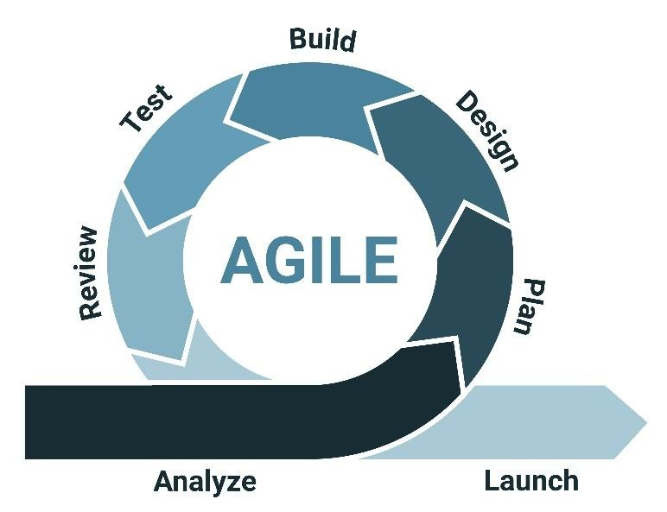
Figure 3.2-1Agile development methodology diagram

Table 3.2-1 Presents the specific objectives of the project and the corresponding approaches that will be applied to achieve each objective
S/N | Specific Objective | Approach
1 | To establish system requirements for the CoffeeChain platform. | Literature review, interviews, and use case modeling.
2 | To design the blockchain-enabled digital records and analytics system. | System architecture design, ER diagrams, and sequence diagrams.
3 | To implement the designed  CoffeeChain system. | Web frontend development, backend logic, and blockchain integration
4 | To test and evaluate the CoffeeChain system. | Unit testing, functional testing and security verification.

2.1 System Implementation
Table 3.2 presents the tools and technologies that will be used for system coding and implementation of the CoffeeChain platform. These tools have been selected to support secure digital record management, permissioned blockchain integration, analytics processing, and webbased system access. Each technology plays a specific role in ensuring system reliability, scalability, and data integrity.
S/N | Tool/Technology Description |  | Purpose
1 | ReactJS | A modern JavaScript library for  building user interfaces | Developing the web-based user interface for cooperative users and administrators
2 | Django | High-level Python web framework | Implementing backend logic, authentication, and system workflows
3 | Django REST  Framework | Toolkit for building Web APIs | Providing RESTful APIs for frontend– backend communication
4 | PostgreSQL | Open-source relational database system | Storing user data, cooperative records, and transactional information
5 | Permissioned Blockchain | Blockchain network with controlled access | Ensuring data integrity, transparency, and tamper resistance of records
6 | Web3 /  Blockchain SDK | Blockchain interaction libraries | Connecting the backend system with the permissioned blockchain
7 | Analytics Module | Data processing and reporting tools | Generating reports and performance analytics for cooperative management
8 | Git & GitHub | Version control tools | Managing source code and supporting collaborative development

3.4 System Testing, Performance Evaluation, and Deployment
Testing is a critical phase in software development that ensures the system is reliable, secure, and function according to the intended requirements before it is deployed for real-world use. In the CoffeeChain project, testing and performance evaluation will be conducted to verify that the blockchain-enabled digital records platform meets the objectives of managing cooperative operations, ensuring data integrity, and supporting analytics for performance monitoring.
The testing process for CoffeeChain will involve three main approaches: Unit Testing, Integration Testing, and End-to-End Testing. Unit Testing will focus on validating individual components, such as login authentication and input validation for email addresses. Integration Testing will ensure that the interactions between different system modules, including API calls and the connection between the web interface and blockchain backend, function seamlessly. Finally, Endto-End Testing will evaluate the complete user workflow, from recording cooperative inputs to generating reports, ensuring that the system performs as expected from start to finish.
Once implementation is complete, the CoffeeChain web application will be hosted to simulate a production environment. This deployment will allow for realistic testing and performance evaluation in an online setting, helping to refine the system into a robust and reliable application ready for cooperative use.
Table 3.4-1 The planned testing and performance evaluation methods for this project
S/N | Action | Purpose | Tool(s) to be Used
1 | Unit Testing | Validate individual system functionalities, such as login authentication and email format validation | Django Test Case
2 | Integration  Testing | Verify API calls and integration of system components to ensure seamless operation according to user requirements | Postman, Web browser
3 | End-to-End  Testing | Evaluate complete navigation flow and user experience of the system | Web browser, Postman

CHAPTER FOUR

COFFEECHAIN SYSTEM ANALYSIS AND DESIGN

4.1 Data Collected
The operational structure of coffee cooperatives was analyzed through Document review, and stakeholder interviews. These cooperatives function as integrated ecosystems involving farmers, management committees, and collection centers coordinated oversight bodies. Their core lifecycle includes farmer registration, input distribution (fertilizers and seedlings), crop aggregation, quality grading, and payment settlement. Mapping this hierarchy was essential to understanding the flow of data from the village level to central authorities.
Deconstructing this workflow helped identify nodes where transparency and immutable recordkeeping are currently absent. The study revealed that the transition of physical goods such as fertilizer or into digital records is highly vulnerable to human error and manipulation. This analysis formed the foundation for CoffeeChain, ensuring its smart contract logic addresses the actual gaps within the Tanzanian coffee supply chain.

4.1.1 Data Collected from Questionnaires
Questionnaires were distributed to cooperative members, agricultural officers, and selected farmers to analyse:
- Current record-keeping methods
- Challenges in data management
- Transparency levels in payment and production records
- Readiness to adopt digital systems
Findings revealed that:
- Approximately 68% of cooperatives rely primarily on manual record-keeping (paper-based ledgers).
- 22% use basic spreadsheet systems.
- Only 10% use partially digitized management systems.

The majority of respondents reported the following challenges:
- 74% experienced data inconsistencies between production and payment records.
- 63% reported delays in accessing historical records.
- 59% expressed concerns about transparency in seasonal payment calculations.
However, 81% of respondents indicated readiness to adopt a secure digital platform if it improves accountability and simplifies reporting.
These findings demonstrated the need for a secure digital records system with tamper-resistant storage and accessible analytics.

4.1.2 Data Collected from Interviews
Interviews were conducted with District Agricultural Officers (DAOs), and coffee farmers belonging to AMCOS in Karagwe to evaluate the current state of subsidies distribution. The findings reveal a transition from paper to digital, yet significant gaps in trust and traceability remain.
- Centralized Government Platforms
Tanzania currently utilizes the Digital Fertilizer Subsidy Distribution System (Ruzuku) and the Integrated Kilimo System (IKS).
  - The Reality: While these systems exist centrally at the Ministry level, they operate as a "Black Box" for the end-user. Data is entered by officials, but farmers have no way to verify if the subsidy allocated to them was actually used by them or diverted.
  - The Trust Gap: Because the database is centralized, records can be edited or "cleared" by system administrators without a permanent audit trail that is visible to the AMCOS or the farmer.
- The Officer-to-Farmer Gap
In regions like Karagwe, the distribution of coffee-specific inputs (seedlings and copperbased fungicides) still relies on the physical presence of Agricultural Officers.
  - There is no Handshake mechanism. An officer may record that 50 farmers received inputs, but there is no digital confirmation (like a USSD PIN or Blockchain Hash) from the farmer to prove the transaction actually occurred.
  - Implementation Lag: While maize and cotton sectors have seen digital pilot programs, coffee production in Karagwe remains largely manual in its verification. iii. Manual Ledger Books (The AMCOS Bottleneck)
Despite national digital shifts, the primary record at the village level remains the Manual Ledger.
  - When fertilizer arrives at an AMCOS warehouse, it is recorded in a physical book. These books are prone to forged entries where inputs are signed for by people who do not exist, or the quantities are inflated.
  - Data Loss: Physical ledgers are frequently lost, damaged, or altered, making it impossible for the Tanzania Coffee Board (TCB) to perform an accurate historical audit of input effectiveness.

4.1.3 Summary of Identified Vulnerabilities
The truth discovered during the data collection phase is that the digitalization of Tanzania’s agriculture is currently top-down and centralized. This leads to:
- Administrative Manipulation: Centralized databases allow for retroactive data changes.
- Lack of Transparency: Farmers cannot trace a bag of fertilizer back to its original batch to verify quality or origin.
- Subsidies are often drained by non-existent farmers because the current systems lack a decentralized proof of receipts.

4.2 System Functionalities
System functionality defines the CoffeeChain platform's capability to execute tasks within the cooperative value chain. It ensures that digital interactions mirror the physical movement of inputs and coffee produce accurately and securely.

4.2.1 Core System Modules
- Identity & Role Management: Managing decentralized identities for farmers and AMCOS staff.
- Asset Tracking: Tracking the lifecycle of inputs and coffee batches.
- Smart Contract Execution: Automating distribution rules and payment triggers.
- Immutable Audit Ledger: Providing a tamper-proof history of all cooperative activities.
- Analytics Engine: Converting blockchain data into actionable insights for the TCB and Cooperatives leaders.

4.2.2 Functional Requirements
The functional requirements specify the system's active behaviors, categorized into Evident (userfacing) and Hidden (internal blockchain logic).
Ref. No Functional Description |  | Category
F1 | USER & IDENTITY MANAGEMENT
F1.1 | Allow registration of Farmers (via IKS ID), AMCOS staff, and TCB auditors. | Evident
F1.2 | Multi-factor authentication for transaction confirmation. | Evident
F1.3 | Assign role-based permissions (for example; Only Clerk can initiate distribution). | Hidden
F2 | INPUT & PRODUCE LEDGER
F2.1 | Record fertilizer distribution linked to a specific Farmer ID. | Evident
F2.2 | Log coffee collection weights and quality grades at the AMCOS center. | Evident
F2.3 | Digital Handshake: Require farmer confirmation (via USSD) for receipts. | Hidden

F3 | BLOCKCHAIN OPERATIONS
F3.1 | Generate a unique cryptographic hash for every input/output transaction. | Hidden
F3.2 | Commit verified transactions to the permissioned ledger | Hidden
Ref No | Functional Description | Category
F1 | USER & IDENTITY MANAGEMENT
F1.1 | Allow registration of Farmers (via IKS ID), AMCOS staff, and TCB auditors. | Evident
F1.2 | Multi-factor authentication for transaction confirmation. | Evident
F1.3 | Assign role-based permissions (for example; Only Clerk can initiate distribution). | Hidden
F2 | INPUT & PRODUCE LEDGER
F2.1 | Record fertilizer distribution linked to a specific Farmer ID. | Evident
F2.2 | Log coffee collection weights and quality grades at the AMCOS center. | Evident
F2.3 | Digital Handshake: Require farmer confirmation (via USSD) for receipts. | Hidden
F3 | BLOCKCHAIN OPERATIONS
F3.1 | Generate a unique cryptographic hash for every input/output transaction. | Hidden
F3.2 | Commit verified transactions to the permissioned ledger | Hidden
F3.3 | Provide a verification tool for farmers to check the immutability of their records. | Evident
F4 | REPORTING & ANALYTICS
F4.1 | Generate Input and Yield performance reports. | Evident
F4.2 | Export cryptographically signed audit reports for regulatory bodies. | Evident
F5 | AUDIT & COMPLIANCE
F5.1 | Maintain a non-deletable history of all record modifications (Audit Trail). | Hidden
F5.2 | Flagging of forgery patterns or distribution anomalies. | Hidden

4.2.3 Non-Functional Requirements
These define the quality and constraints of the CoffeeChain environment, focusing on the unique challenges of rural connectivity and data integrity.
Table 4.2.3-1 Non-Functional Requirements for CoffeeChain
Attribute | Non-functional Requirement
Security | Immutability: Once a transaction is validated, it cannot be altered.  Encryption: All personally Identifiable Information must be hashed.
Integrity | Consensus: Transactions must be validated by multiple nodes (AMCOS/TCB) before finality.
Usability | The interface must support English and Swahili for ease of use villages (Karagwe)
Performance | Transaction confirmation should occur in under 10 seconds.
Availability | The system allows Offline Queueing for areas with poor internet, syncing once back online.
Scalability | The architecture must support the addition of new AMCOS nodes without degrading speed.

4.3 Non-Functional Requirements
In systems analysis and design, system actors are the external entities that interact with a system in order to achieve defined goals. Actors may represent individuals, organizational roles, or external systems that initiate, receive, or influence system processes. Our system consists of two main types of actors, namely primary actors and secondary actors.
The CoffeeChain system operates within the Agricultural Marketing Cooperative Society (AMCOS) structure. While AMCOS is the primary institutional stakeholder, interaction with the digital platform occurs through designated representatives who act on behalf of the cooperative. The following subsections analyse the individual actors involved in the system and their respective responsibilities.

4.3.1 Primary actors
Primary actors are those who directly initiate operational transactions and interact with the system regularly.
- AMCOS Clerk (Operational Representative)
While AMCOS is the primary institutional stakeholder, interaction with the digital platform occurs through designated representatives who act on behalf of the cooperative. The AMCOS Clerk represents the cooperative in dayto-day operational activities within CoffeeChain. This actor serves as the primary initiator of input distribution transactions and production data recording. He is also responsible for registering incoming agricultural input batches and documenting their allocation to registered farmers, but also recording production quantities delivered by farmers when required.

- Farmer (End User and Producer)
The farmer confirms receipt of agricultural inputs, submits or confirms seasonal production data, all of which is stored in a relational database and cryptographically anchored to the blockchain. Farmers do not have privileges to edit or delete historical records rather their role strengthens decentralized validation while preserving data integrity.

4.3.2 Secondary actors
Secondary actors participate in governance, oversight, or infrastructure management rather than routine operational tasks.
- Tanzania Coffee Board (TCB) and District Agricultural Officer (DAO) (Regulatory Actors)
Regulatory actors, including representatives from the Tanzania Coffee Board (TCB) and District Agricultural Offices, are granted read-only access to CoffeeChain to perform oversight and compliance monitoring by utilizing the system's reporting tools, they can review total input distributions, farmer production quantities, and the correlation between allocations and actual outputs to identify anomalies suggesting irregularities. Because all transaction hashes are anchored to a permissioned blockchain, regulatory bodies rely on immutable digital records rather than manually compiled paper reports.
- System Administrator
The System Administrator serves as the technical custodian of the CoffeeChain platform, focusing on maintaining system operational integrity rather than participating in agricultural activities. Key responsibilities include managing user accounts and enforcing role-based access control to ensure secure system entry. This actor is also tasked with maintaining node connectivity within the permissioned blockchain network and monitoring system logs to ensure optimal performance. Furthermore, the administrator manages the critical API integration between identity systems and blockchain addresses.

Table 4.3.2-1 System Actors for CoffeeChain
Actor | Description
Farmer | Acts as the end-recipient and primary validator, responsible for confirming the physical receipt of agricultural inputs and submitting seasonal coffee production data.
Cooperative Staff  (AMCOS Clerk) | Responsible for the operational entry of distribution records. They initiate the "digital handshake" by assigning input batches to farmers and recording harvest quantities delivered to the cooperative centers.
System  Administrator | A technical role focused on platform maintenance rather than agricultural operations. Responsibilities include managing role based access control (RBAC), maintaining blockchain node connectivity, and ensuring the integrity of API integrations between the database and the ledger.
Oversight Authority  (TCB/DAO) | Regulatory bodies granted high-level visibility to monitor cooperative compliance. They utilize the blockchain to verify that distributed inputs correlate with reported production levels, allowing for the detection of supply leakages or "ghost" records without requiring physical presence.

4.4 Use Case Diagrams and Use Case Description
A use case describes how system actors interact with CoffeeChain to accomplish operational objectives.
The focus of CoffeeChain is not automation of transactions, but the controlled documentation, verification, and auditability of input distribution and production data. Therefore, the most critical aspect of use case modeling in this project is the interaction pattern between actors, particularly how responsibilities are distributed and validated across multiple levels.
The primary operational interactions are categorized into three core use cases:
- Distribution of Agricultural Inputs
- Production Data Logging
- Supply Chain Audit and Reporting
- Manage User Accounts
- Assign Roles and Permissions
- Register and Maintain Blockchain Nodes

4.4.1 Use Case 1: Distribution of Agricultural Inputs
This use case is fundamental to the system’s traceability objective. By anchoring the distribution event to a permissioned blockchain ledger, the platform prevents retroactive manipulation of supply records and enables downstream analytics comparing distributed inputs against production output.
Table 4.4.1-1 Distribution of Agricultural Inputs use case
Field | Details
Use Case | Distribution of Agricultural Inputs
Actors | AMCOS Clerk, Farmer
Description | Records the transfer of agricultural inputs (e.g., fertilizer, seedlings) from the cooperative to a registered farmer. The transaction establishes a verifiable and immutable record linking the farmer to the distributed inputs.
Precondition | Clerk is authenticated;  Input batch is registered in the system;  Farmer is registered with valid identification details;  Available inventory exists.
Main Flow | - Clerk selects input type and batch ID  - Clerk enters Farmer ID  - System verifies farmer registration and farm size eligibility  - System updates cooperative inventory  - Transaction data is hashed  - Hash is written to the permissioned blockchain ledger.
Post condition | Input ownership record is immutably stored;  Cooperative inventory is decremented;  Audit trail is created linking farmer and input batch.

4.4.2 Use Case 2: Production Data Logging
This use case operationalizes the accountability mechanism of CoffeeChain by creating a verifiable link between inputs distributed and harvest achieved, the system enables analytical assessment of productivity trends and anomaly detection without introducing financial processing components.
Table 4.4.2-1 Record Seasonal Coffee Production use case
Field | Details
Use Case | Record Seasonal Coffee Production
Actors | Cooperative Staff, Farmer
Description | Captures seasonal harvest output and links it to inputs received to analyze production efficiency and detect irregularities.
Precondition | User is authenticated;  Farmer has a history of received inputs;  Production season is active.
Main Flow | - User selects farmer  - User enters harvest weight (kg)  - System retrieves historical input records  - System correlates production with input history  - Record is hashed → 6. Hash is written to blockchain.
Post condition | Harvest record is permanently stored;  Data is cryptographically secured against retroactive changes;  Production record is linked to input distribution history.

4.4.3 Use Case 3: Supply Chain Audit and Reporting
This use case demonstrates the auditability advantage of a permissioned blockchain architecture since data entries are cryptographically hashed and time-stamped, supervisory authorities can verify operational consistency without relying solely on cooperative-reported summaries.
Table 4.4.3-1 Generate Supply Chain Audit Report use case
Field | Details
Use Case | Generate Supply Chain Audit Report
Actors | Agricultural Officer, TCB Representative
Description | Provides oversight visibility into cooperative input distribution and production performance using immutable ledger records.
Precondition | Auditor is authenticated with appropriate access privileges; Ledger contains distribution and production records.
Main Flow | - Auditor selects cooperative and reporting period  - System retrieves immutable distribution records  - System retrieves linked production data  - System aggregates and analyzes records  - System generates structured audit report.
Post condition | Report reflecting verified ledger data is generated;  Discrepancies or anomalies are highlighted;  No ledger data is altered during report generation.

4.4.4 Use Case: Manage User Accounts
This use case enforces controlled system access and supports accountability by maintaining traceable user identities within the permissioned environment.
Table 4.4.4-1 Manage User Accounts use case
Field Details
Use Case | Manage User Accounts
Actors | System Administrator
Description | Creates, updates, deactivates, and maintains system user accounts to enforce role-based access control.
Precondition | Administrator is authenticated with elevated privileges.
Main Flow | - Administrator selects account management function  - Enters user details  - Assigns role (Clerk, Farmer, Auditor)  - System validates role assignment  - Account is created or updated.
Post condition | User account is securely stored; Access permissions are enforced.

4.4.5 Use Case: Assign Roles and Permissions
This use case ensures that each actor can only perform functions consistent with their institutional responsibilities, thereby protecting system integrity and preventing unauthorized operations. Table 4.4.5-1 Assigning Roles and Permissions use case
Field | Details
Use Case | Assign Roles and Permissions
Actors | System Administrator
Description | Configures role-based access rights to ensure users only perform authorized operations.
Precondition | Administrator is authenticated;  Role definitions exist in system configuration.
Main Flow | - Administrator selects user  - Assigns role  - Defines access scope  - System validates consistency  - Permissions are updated.
Post condition | Access control policies are updated; Unauthorized access is restricted.

4.4.6 Use Case: Register Blockchain Node
This use case ensures that only verified cooperative or regulatory entities participate in consensus processes, thereby strengthening data immutability and auditability across the system.

Table 4.4.6-1 Registering Blockchain Node use case
Field | Details
Use Case | Register Blockchain Node
Actors | System Administrator
Description | Configures and maintains permissioned blockchain nodes representing cooperative or regulatory entities.
Precondition | Administrator has infrastructure-level access; Node credentials are available.
Main Flow | - Administrator registers new node  - System validates node identity  - Node is added to permissioned network  - Synchronization with ledger occurs.
Post condition | Node becomes an active participant in consensus; Distributed ledger integrity is maintained.

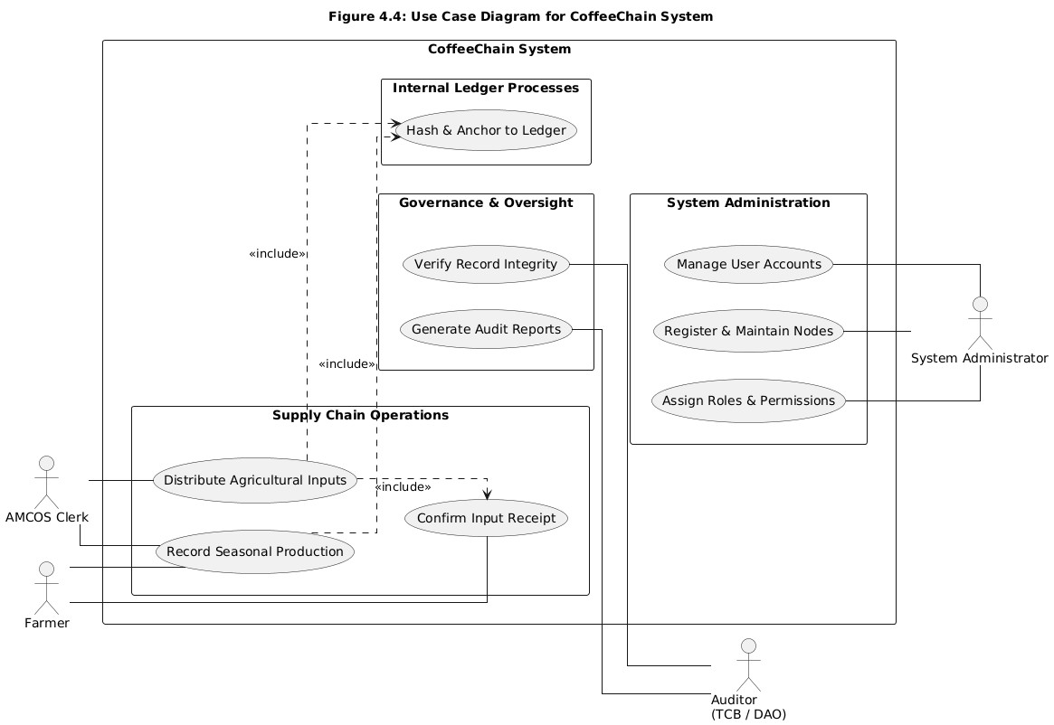
Figure 4.4.6-1 Use case of Diagram of CoffeeChain system

4.5 Sequence Diagrams
A sequence of diagrams refers to a series of visual representations that illustrate a process, progression or transformation of a system, concept or set of data over time or steps. Figures 4.2
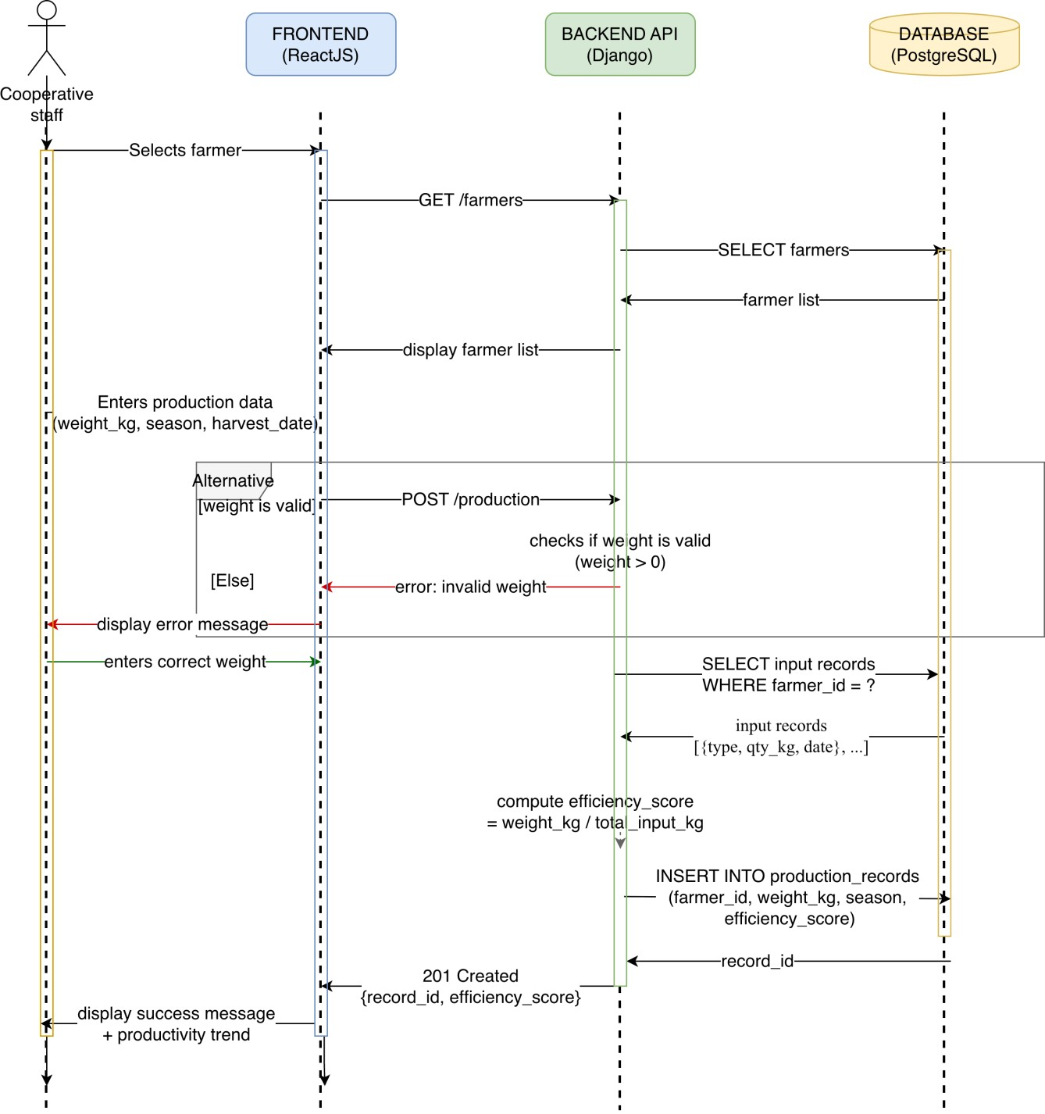
through Figure 4.5 are some of sequence diagrams for the CoffeeChain blockchain based system.
Figure 4.4.6-2 Production logging

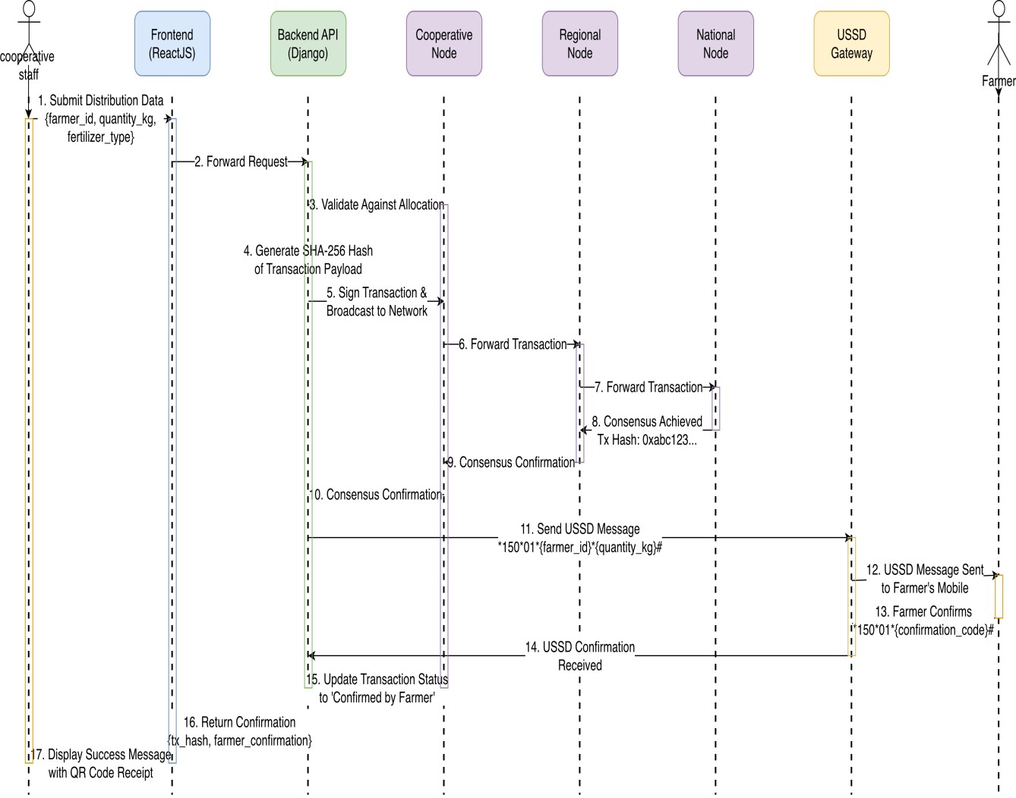

Figure 4.4.6-3 Record Fertilizer distribution with USSD farmer confirmation

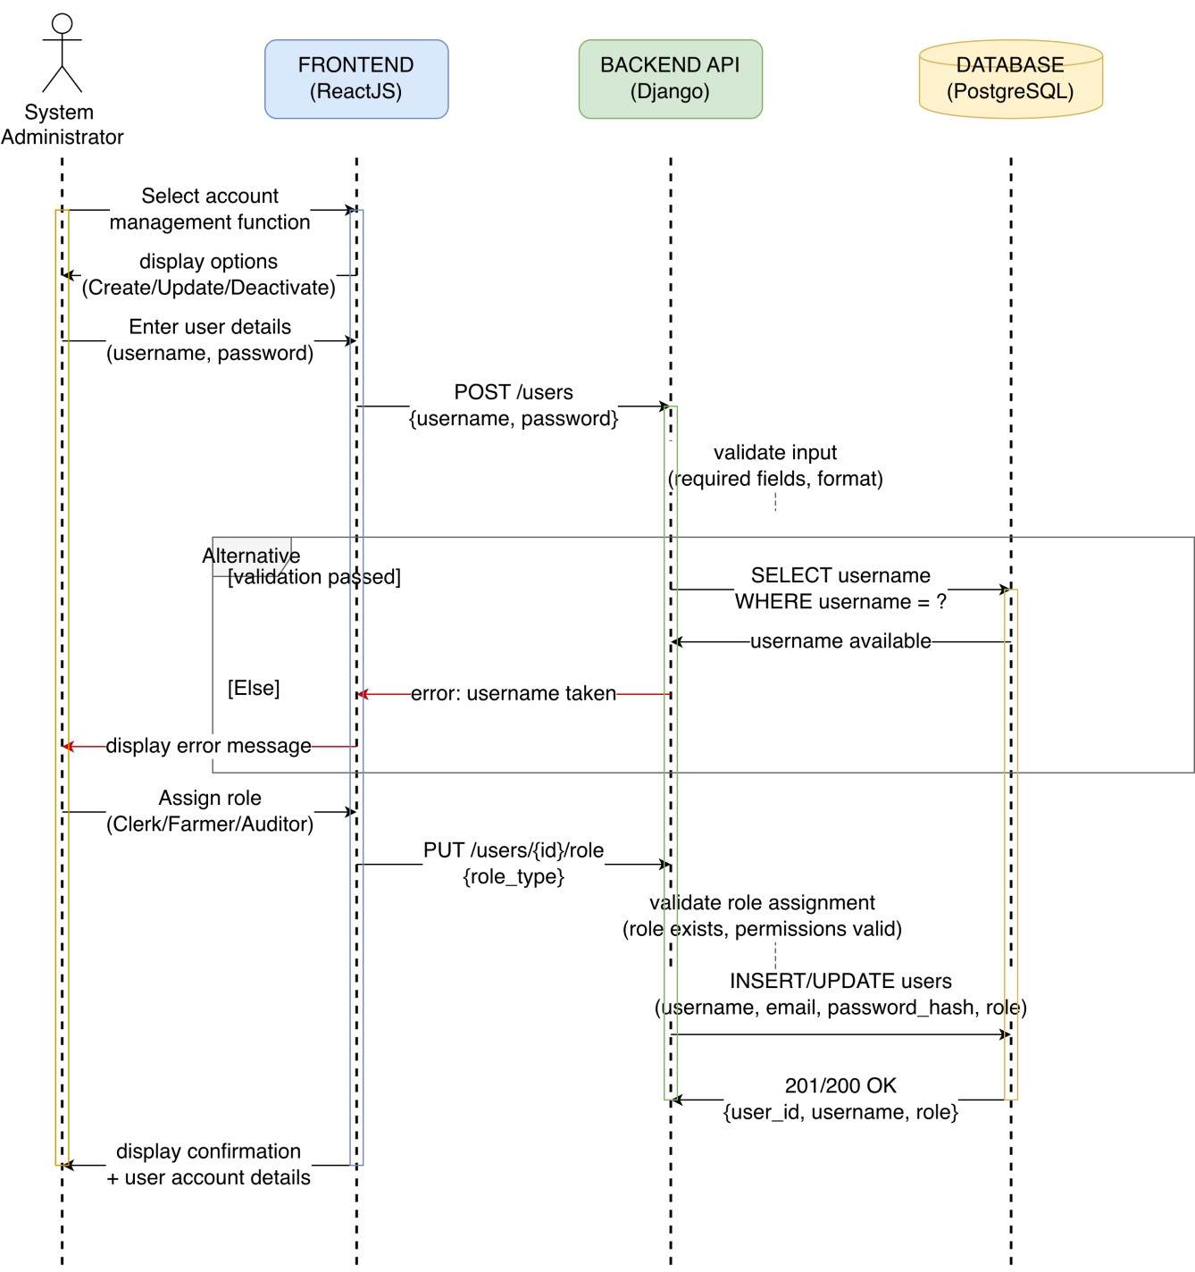
Figure 4.4.6-4 Managing user account sequence diagram

4.6 Class Diagrams
A UML Class diagram as shown in Figure 4.6 that represents the structure of a system by showing its classes, attributes, methods and relationships (such as inheritance, association and dependencies). It is used in object-oriented design to model software architecture. Figure 4.6 CoffeeChain system Class Diagram.

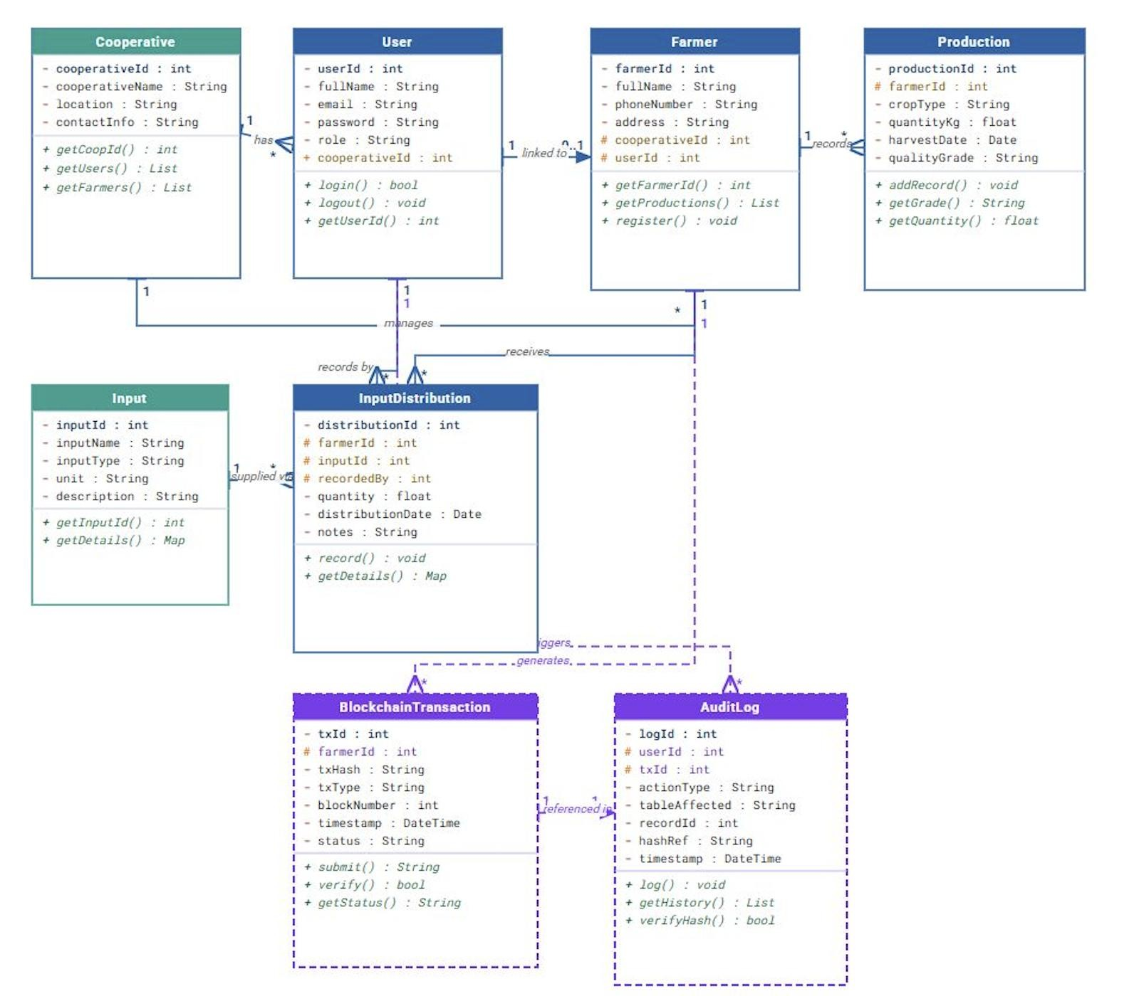
Figure 4.4.6-5 CoffeeChain system class diagram

4.7 Entity Relationship Diagram (ERD) The ERD illustrates database structure including:
Entities:
  - Users
  - Farmers
  - Production
  - Inputs
  - Blockchain_Transactions
  - Audit_Logs
Primary keys and foreign keys establish relationships between farmers and transactions (Refer to Figure 4.6).

Table 4.4.6-2 Entity Relationship Diagram illustrating database structure

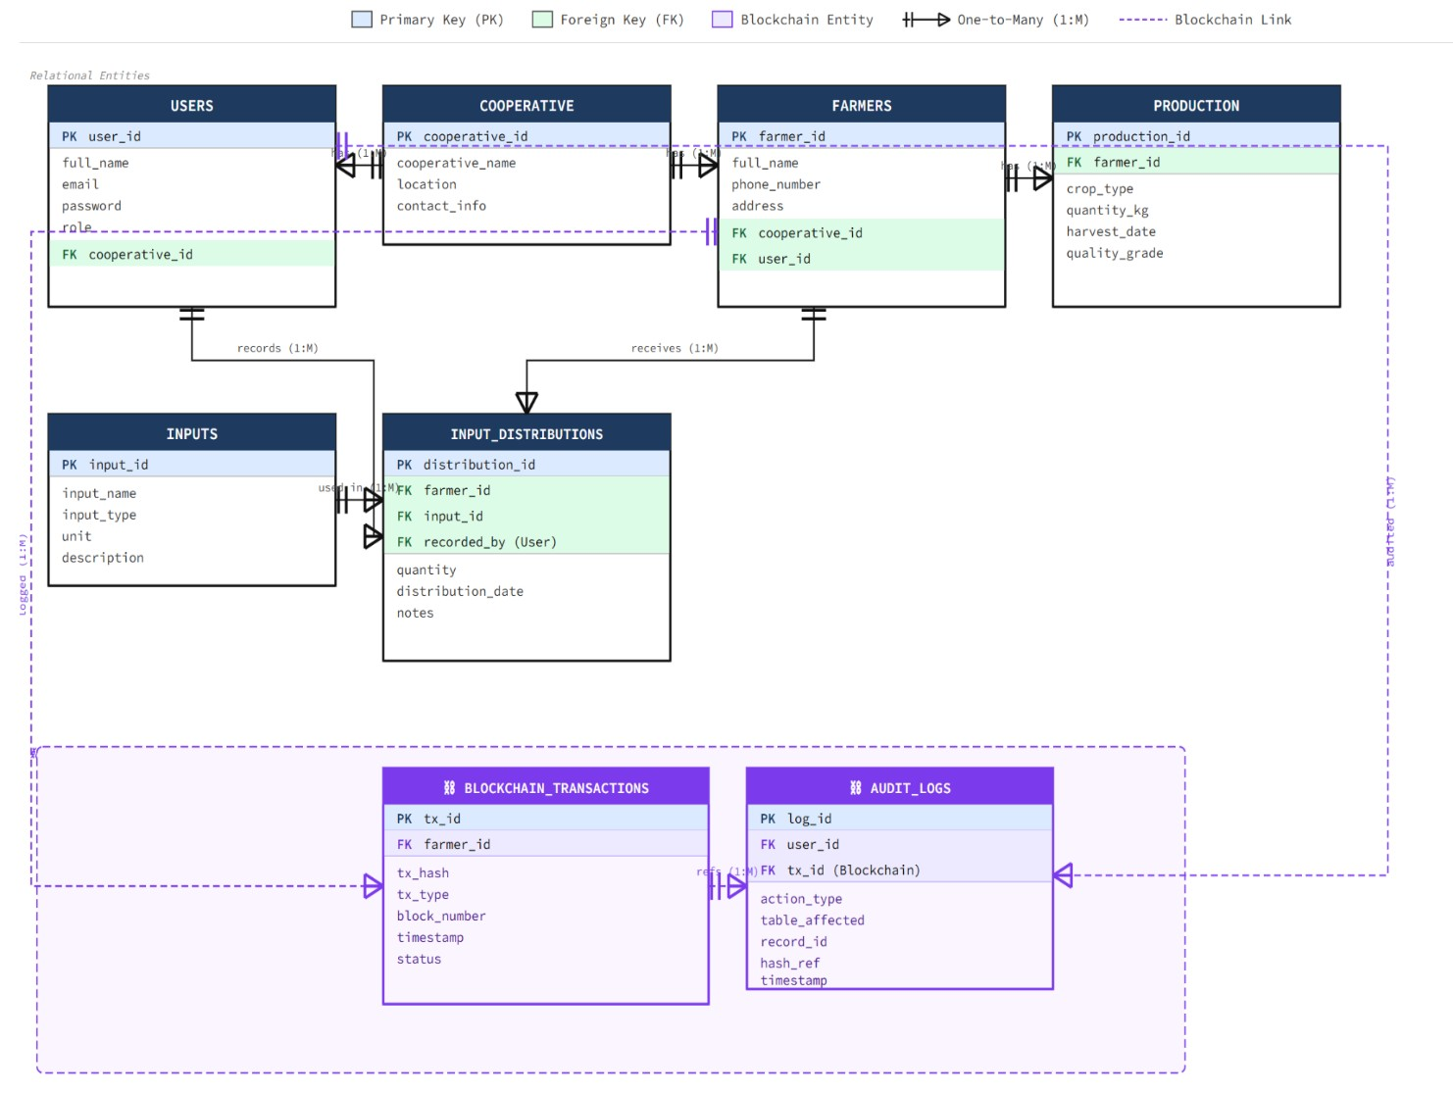

4.8 Database Architecture
Database architecture refers to the high-level design of the database system including the conceptual, logical, and physical levels of data organization. A database stores information and helps access data quickly and securely.
CoffeeChain adopts a three-tier architecture consisting of:
- Presentation Layer (Frontend Web Interface)
- Application Layer (Backend & Blockchain Logic)
- Data Layer (Relational Database + Permissioned Blockchain Network)
The relational database stores structured cooperative data, while the permissioned blockchain stores cryptographic hashes of critical transactions to ensure immutability and transparency.
This architecture ensures:
- Secure data handling
- Clear separation of concerns
- Scalability for future cooperative expansion
- Integration of blockchain without replacing the relational database
Figure 4.7 illustrates the CoffeeChain system architecture.

References
FurtherAfrica. (2023, October 4). Dimitra: Applying Blockchain to Redefine Agriculture in Africa. Retrieved from FurtherAfrica: https://furtherafrica.com/2023/10/04/dimitra-applyingblockchain-to-redefine-agriculture-in-africa/
Nations, F. a. (2019). Blockchain Application in Agriculture: Opportunities and Challenges.
Rome: FA0.
Nations, F. a. (2022). The State of Food and Agriculture 2022: Leveraging Digital Technologies for Agricultural Transformation. Rome: FAO.

